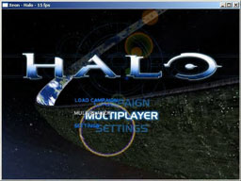
This is an emulator for the X-BOX platform. Xeon runs only one commercial game and it is Halo NTSC version, it plays very roughly, the images are too slow to get in game, of course the emulator is still under development so let’s expect more for this great emulator.
If you want to run it properly, it is strongly recommended to have the next:
- Windows XP
- Latest DirectX
- Pentium 4 2.0Ghz
- 1024mb RAM
- Recommended Video Cards: GeForce FX or Radeon 9200 Pro or higher

