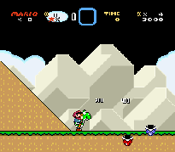
At the time this page was created I did not know much about SnEM. All I knew was that it was a very good SNES emulator. Definitely worth a try! For more information about features & controls please read the readme file that comes with the emulator.

