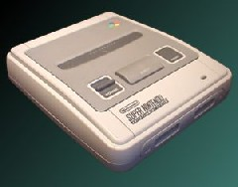
The Super Nintendo Entertainment System was Nintendo's first 16 bit gaming console that was originally released in Japan.
Specs:
- CPU: 65c816 (16-bit)
- CPU speed: 2.68 and 3.58 Mhz
- RAM memory: 1 Mbit (128 Kbyte)
- Picture Proc. Unit: 16-bit
- Video RAM: 0.5 Mbit (64 Kbyte)
- Resolution: 256x224 512 x 448 pixels max hi res and interlaced modes
- Colors Available: 32,768 colors
- Max colors on screen: 256 colors
- Max sprite size: 64 x 64 pixels
- Max sprites: 128
- Min/Max Cart Size: 2 Mbit - 48 Mbit
- Sound chip: 8-bit Sony SPC700
- Sound channels: 8, uses compressed wave samples

