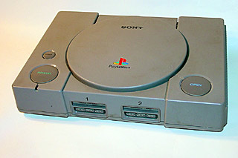
The Sony Playstation... There are so many things we can say about it but most of you know about it so let's just go to the specs & emulators.
Specs:
- Analog Joystick
- Controller
- Memory Card
- Link Cable
- Mouse with Pad
- RFU Adaptor
- Multitap Unit
- R3000A
- 32 bit RISC processor
- Clock- 33.8688MHz
- Operating performance - 30 MIPS
- Instruction Cache - 4 KB
- Data Cache - 1 KB
- BUS - 132 MB/sec.
- Data Transfer Rate (DMA TO RAM) 150 KB/sec. (Normal) 300 KB/sec. (Double speed)
- Maximum Capacity - 660 Megabytes
- Features Audio CD play XA Interactive Audio
- Control Pad Two control pad connectors Expandable with multitap connector
- Backup RAM Two removable cards 128 KB Flash Memory OS support for File Save, Retrieve and Remove
- Serial Port I/O Link Cable Connectivity
- Main RAM: 2 Megabytes Video RAM: 1 Megabyte Sound RAM: 512 Kilobytes CD ROM buffer: 32 Kilobytes OS ROM: 512 Kilobytes
- 24 Channels
- 44.1KHz sample rate
- PCM audio source
- Digital effects include: Envelope Looping Digital Reverb
- Load up to 512K of sampled waveforms Supports MIDI Instruments

