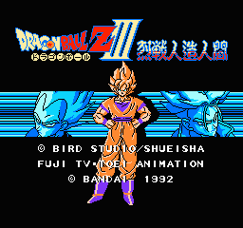
This is a nice emulator with many features, including a "eagle" mode which should make games look better. On my old PC I noticed RockNES wasn't particularly fast. But with both the advance of PC's and RockNES the speed difference (compared to other emulators) should be negligible.
After the first run, RockNES creates a ROCKNES.CFG file which can be edited with any text editor to set options for sound, video, controllers etc.
RockNES also supports the Game Genie, see the ROCKNES.TXT file included in the ZIP file for more information on how to use Game Genie codes with RockNES.

