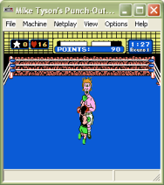
Nestopia is one of the best Nintendo/Famicom emulators available, it’s an open source emulator and it gets updated frequently. The Windows port has been completely rewritten from scratch, which means it has been improved, also the emulation core has changed completely.
It has a great game compatibility list and the supported controllers make this emulator a nice option for playing your favorite games.
Another great thing about this emulator is that netplay is supported through the Kaillera network. Just remember before you start playing games in netplay, make sure that you and your gaming pals are using the same emulation settings.
The minimum requirements are:
- Processor: Pentium MMX or comparable AMD
- Ram: 64MB
- Video: Direct3D 9.0 compatible graphic card.
- OS: Windows 98/Me/2000/XP
- Software Installed: DirectX 9.0c or superior.

