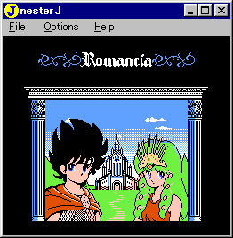
NesterJ is part of the Nester family, a group of emulators based on the emulator NesterJ created by Darren Ranalli. As you might have guessed from the "J" in the name, this spin off is of Japanese origin. Fortunately it is in English though.

