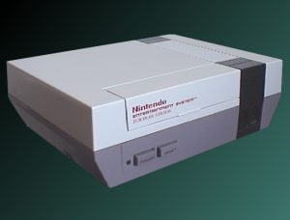
The Nintendo's 8 bit console was Sega's biggest rival for its Master System which was a huge hit as well at the time.
Specs:
- Processor: 6508 8-bit (using a custom Motorola 6502 class)
- Processor speed: 1.79 Mhz
- Resolution: 256x224 (ntsc) or 256x239 (pal)
- Colors available: 52
- Max Colors on screen: 16, 24 or 25.
- Max sprites: 64
- Max sprites per line: 8
- Sprite size: 8x8 or 8x16
- Picture Scroll: 2 h.v
- RAM: 16 Kbit (2kb)
- Video RAM: 16 Kbit (2kb)
- Min/Max cart size: 192 Kbit - 4 Mbit
- Sound: PSG sound, 5 channels
2 square wave
1 triangle wave
1 noise
1 PCM

