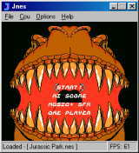
This is a cool Nintendo NES emulator for Windows.
The system requirements are higher compared to other emulators. Jnes requires at least a Pentium 133 (MMX preferred) and a good video card with 2D acceleration.
For Jnes to work properly, you also need to have the latest drivers (video, sound, DirectX) installed. Failing to do so might cause strange problems.

