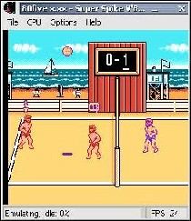
80five is the new version of MarioNES. Unlike MarioNES this version has been changed a lot so the author has decided to release it as a new emulator. If you liked MarioNES you really need to try this one!

