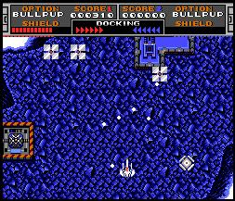
RuMSX is a freeware MSX emulator for Microsoft Windows.

Minimum Requirements
Minimum requirements:
- 80386 with 4MB RAM (for Windows 95)
- Windows 95 or Windows NT 4.0
Recommended:
- Pentium 166 with 32MB RAM
- Windows 95 with DirectX 3 or Windows NT 4.0 with SP3 - or higher versions
- Mouse & Joystick
- FM/MIDI and Wave capable sound-card
- Video capture card

