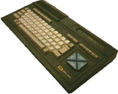
MSX is a Z80-based family of home computers which appeared in 1982. They were popular in Asian, South American and European countries as well as the former Soviet Union, but they are virtually unknown in USA. The MSX2, MSX2+ and TurboR editions were released before the "death" of the system around 1988.
Useful Sites:
Generation MSX
MSX Resource Center

