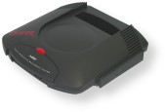
The Atari Jaguar was released in the United States on December of 1993. The console was manufactured and distributed by IBM. Atari highly boasted the system as being the first 64-bit console. They also boasted about a host of developers and a hundreds of games being created for the system.
The system had amazing technical specs for it’s time. The console contained 5 processors mounted on 3 chips. One was a traditional Motorola 68000, and the other two were nicknamed ‘Tom’ and ‘Jerry’.
The use of the Motorola 68000 was a reason that the Jaguar’s validity as a 64-bit was put to question. You see the Motorola 68000 is a 16-bit processor, and 2 others were 32-bit. Only 2 processors were actually 64-bit, but all the registers and buses were in fact 64-bit.

