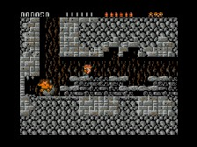
Yet another Game Cube emulator for Windows written using C++.
WhineCube is able to load and execute DOL, ELF or GCM format executables with graphics, pad, DVD and sound emulation.
Requirements:
- Windows XP or later.
- Latest DirectX available.
- A graphics card that support D3DFMT_YUY2 conversion (something like a GeForce 256 or newer).
This emulator does not run any commercial games yet, but you can try a few homebrew such as Pong pong.dol and Wireee wireee.dol.
You can find a compatibility list at the official site. Some of them may require a cache hack

