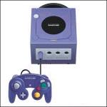
Nintendo's first ever console to use a disk system for loading games is the 128-bit Gamecube. It competes with Sony's Playstation 2 and Microsoft's XBox.
Specs:
- Contemporary cube shape
- 4 controller ports
- 2 memory card slots
- Capacity for future modem/broadband connection
- 485MHz custom CPU with 162MHz custom graphics processor
- 40MB total memory; 2.6 GB per second memory bandwidth
- 12M polygons per second; texture read bandwidth 10.4 GB per second
- 64 audio channels
- Dimensions 4.5" x 5.9" x 6.3"
- 3-inch Optical Disc Technology (1.5 gigabytes)
Be warned that there have been many fake emulators, so be careful when you download one from any site other than ours.

