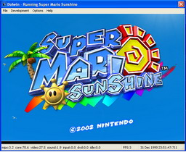
Dolwin is an open source Game Cube emulator fully written with C.
Even though it's still under development you can still be able to boot and run some commercial games and a few demos.
The zip file comes with a demo that you can play to test the emulator. Since the Game Cube system is still new to emulate it perfectly, remember not to expect a good emulation with commercial games, some may run and some may not.

