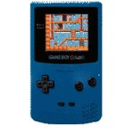
The most well known portable gaming device in the world is Nintendo's Gameboy. Originally released in the late 80's it has sold more than any other portable game console in the world. Several years later Nintendo released the "color" version of the all time classic!
Specs (of the Gameboy Color model):
- Processor: Z80 Sharp processor
- Processor Speed: 8 MHz
- RAM: 32K
- Video RAM (VRAM): 16K
- Colors Available: 32,000
- Colors On Screen: 10, 32, or 56
- Resolution: 160x144 @56 colors and 320x288 @24colors
- Sound: 4-channel FM sound
- Controls: 8-directional D-Pad, A, B, select, and Start buttons
- Power: 10+ hours on 2 AA batteries. AC adapter separately available

