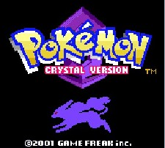
BasicBoy is an emulator written for GameBoy and GameBoy Color made in pure Microsoft Visual Basic 6 and VB.NET

