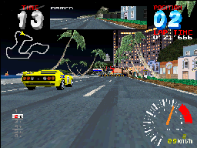
VivaNonno is a Namco system 22 emulator for Windows and DirectX. Supported games are "RIDGE RACER 2" (Japan-A, Japan-B) and "RAVE RACER" (Japan-A, Japan-B, World-B).

