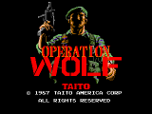
Raine is a arcade emulator which emulates some games which use M68000 or M68020 CPU's. The main focus is on emulating Taito and Jaleco games.
The emulator is well written and is capable of emulating some games which MAME can't emulate. Some games which are playable with this emulator are classics like Operation Wolf and Darius.
Unfortunately the emulator was discontinued by it's original author. He released the source code however, and other people have since then continued to work on the emulator. As a side effect ports now exist for Windows and Linux.

