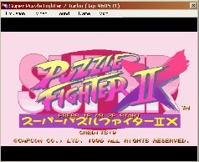
Nebula is a Neo Geo, CPS1/2, Konami and PGM(PolyGameMaster) emulator. It's one of the best as it allows multiple players, net play and cheats. If you are good at programming you can also add games that are not included but are supported at the game list using Dat files.
The emulator is using the MAME naming system so any MAME compatible game that is supported should have the same name.

