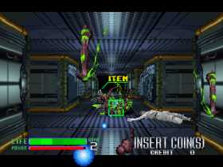
The world's most famous emulator is without a doubt MAME! Just imagine that it plays more or less around 3000 games and it keeps going! With it you can play the most classic games that you loved so long ago.
Below you can find the command line version of MAME along with one of the best frontends(use it only if you like frontends) or you can always use MAME32! MAME32 has an integrated frontend and it's much easier to use.
Whether you like emulators or not if you are a fan of all those old games then MAME might be your last chance to play them again.

