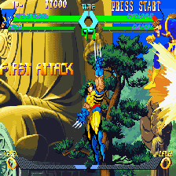
Kawaks has been one of the emulators of choice for newer games such as Metal Slug 3. This emulator supports both Neo-Geo and Capcom (CPS1/2) games. This can probably be considered the ePSXe of arcade emus; some configuration must be done prior to actual gaming, but once that's out of the way, the playing can begin!
Among Kawaks' primary features is netplay, something that makes gaming so enjoyable. Do you feel a need to find a guy to terrorize aliens? Hop on to a server and blast away! Want to have a one-on-one with a friend in Marvel vs. Capcom? Netplay is your answer.

