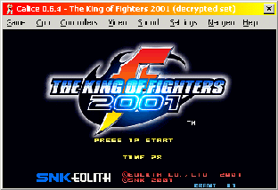
Calice is a Capcom CPS-1, Capcom CPS-2, Sega System 16, Sega System 18, SNK Neogeo and Gaelco System 1 emulator. It's good and frequently updated. What more do you want?

