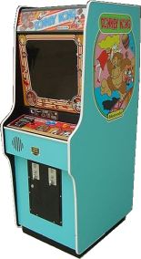
When we say arcade emulators we refer to our well known coin up systems. The machines themselves come in a big variety of hardware and constantly evolve. Please note that some games may be easy to emulate and others not. If you really want to play one of the games that are not emulated yet you just have to wait until somebody manages to do it.

