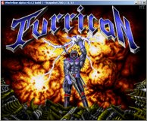
WinFellow is a Commodore Amiga emulator that has high compatibility and supports all existing models.
If you have any problems configuring it here is the default Amiga 500 configuration:
- 68000 CPU at 7 MHz
- 1 Floppy drive (disable the others!), leave "Fast Disk-DMA" unchecked
- 512k Chip and eventually 512k Bogo RAM
- Kickstart 1.3 or 1.2
- Normal, delayed OCS blitter
- no filesystems or hardfiles, "disable autoconfig-devices"
For more information please visit the official site.

