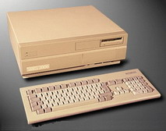
The first Amiga (model A1000) was introduced in 1985 by Commodore. Some of the operating systems available for the Amiga series were AmigaOS, Linux, and NetBSD.
Due to the large number of models if we were to list specs for every model then the page would get quite big.
Existing models (list may be incomplete): Amiga 1000, Amiga 500, Amiga 2000, Amiga 500+, Amiga 2500, Amiga 3000, Amiga 600, Amiga 1200 and Amiga 4000.
Good sites to visit: Amiga.org, AmigaWorld

